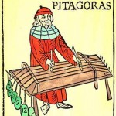Pythagoras, perhaps listening to the sounds of tradesmen at work, started thinking about sounds that were pleasing to hear. We can imagine him watching a blacksmith strike an iron rod to make a sword and noticing that different length blades produced a different sound. Logically he would conclude that the length of a string on an instrument could determine the kind of sound that the instrument produces. These different kinds of sound eventually became known as different notes.

As he went about observing the sound an instrument produced with different length strings, he observed that if the change in length could be represented by a whole number ratio the relating note of music was also pleasing to the ear and harmonious when combined with other notes. Ratios like 9:8, 5:4, 4:3, 3:2, 5:3, 15:8, and 2:1 that today we call Pythagorean Intervals, were at that time recognized for their quality and without the knowledge of sound waves and frequency attributed to gods.

Today we understand wavelengths and can measure their frequencies. If we use a spectrophotometer to measure the frequency of an A note on a violin we should get a reading of 440 hz. Given the 32.5 cm length of the violin string to get to the E note, using Pythagorean Intervals, we shorten the string to 21 and 2/3 cm (32.5*2/3). If we then measure the frequency of the E note, we should get a reading of 660 hz. That “given two notes their frequencies and string length is inversely proportional” is a mathematical representation of the fact that the string producing the E note would be vibrating twice as fast then when it was outputting an A note . Proper fractions and inverse relationships maybe some of the more sophisticated examples of math in music yet at the most basic level each performance starts with “a 1”, “a 2”, “a 1 2 3 4”.

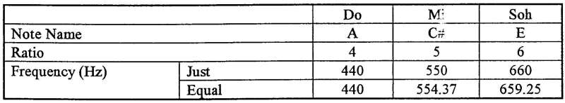

|  |  |
| --- | --- |
| 12/01/2013 | Waldorf School: Mathematics  <http://www.youtube.com/user/waldorfmathematics?feature=watch>  Roland Piano  <http://www.novelmusic.com/roland/Technical/> |